






Throughout the past year Mrs Peckham (SENCo) has been responsible for Special Educational Needs and Disabilities (SEND). To find out more about SEND at St James First School and Nursery, browse through the report below, have a look at our SEND Policy which can be found on the school website or contact Mrs Peckham in person on rpeckham@stjames.dsat.org.uk. The report contains a review of the last year at
St James’ and a look at how children are identified as having SEND, how we work with parents and pupils and how children are supported in school.

SEND Information Report
2024-2025

How did SEND support help in 2024-25?
Mrs Peckham’s role is to think about what worked well for pupils with SEND, what didn’t work so well and what we need to change. Below you will find some of these things and a plan of things that need to change in 202

- Further develop the schools universal offer to pupils and initial concerns procedure.
- Greater use of DSAT assessment tools and pathways to inform targets.
- Training for all staff on relation based informed approaches.
- Develop early identification and professional discussions in nursery through PPM’s

- IEPs' written and reviewed every 6/7 weeks. This helped pupils to have short measurable targets and staff to have a clear idea of who was achieving their targets and who was not.
- A greater understanding in staff in identifying and addressing barriers rather than supporting labels / diagnoses.
- Greater clarity about what a SMART (Short, Measurable, Achievable, Relevant, Time based) targets are and how to write them.

- Quality First teaching in every class.
- Teachers' knowing their pupils and making sure they plan carefully for them.
- Mrs Peckham meeting with experienced SENCOs' within our DSAT Trust.
- Working with other professionals.
- Regular short sharp interventions following the lesson to enable pupils to access the next lesson.
What was great and needs to stay the same?
What we changed and why?
What we plan to do in 2025-26?
What are the Needs at St James and how are they supported?

- Learning difficulties at St James can take a variety of types, commonly including – Specific Learning Difficulties (SpLD) – this term indicates that pupils display differences across their learning. Pupils with SpLD may have a particular difficulty in learning to read, write, spell or manipulate numbers so that their performance in these areas is below their performance in other areas. Pupils may also have problems with memory, organisational skills and with co-ordination. Pupils with SpLD cover the whole ability range and the severity of their impairment varies widely. SpLD include Dyslexia, Dyscalculia and Dyspraxia.
- A range of techniques will be used to make the curriculum appropriate for all learners. The SENDCO will advise teachers on support, where necessary.

- There is a wide range of difficulties which fall within the category of communication, including Autism and Speech and Language difficulties.
- Many pupils with Communication and Interaction difficulties will be catered for by in-class support and adaptations in class with advice from the SENCO and external specialists if required.
- Within the school setting, Speech and Language Therapists (SALT) from the NHS assess children with Speech and / or Language difficulties who have been referred to them by the school or another agency. They discuss their findings with the parent and class teacher as well as the SENCO. Targets are set by the SALT with resources suggested or provided.
- For children with more complex speech and language difficulties, the NHS Speech and Language therapist may provide some therapy sessions which are usually provided in school with a therapy assistant. Therapy sessions, whether carried out by a Therapist or assistant, focus on set targets and use flashcards, games, apps and exercises to encourage children to use the correct mouth shapes, correct grammar etc. It is vital that parents and school staff are involved as much as possible to ensure the child can apply skills across the day.

- There is wide range of needs in this area including: ADHD, social difficulties, anxiety, behavioural difficulties etc. Support we can provide in school may include:
- Time to talk / be supported by their teacher, a TA or Emotional Literacy Support Assistants (ELSA)
- Nurture groups and Working Together
- Social skills and friendship groups
- ‘Pupil voice’ – we give time to children to share what helps them most effectively in school
- Behaviour programmes including rewards and sanctions.
- The Specialist teacher service have behavioural specialists where appropriate to ensure that support is effective and appropriate for the child.

- When a child has an identified sensory, physical or medical need we will ensure that:
- All working with the child understand the specific needs of the child.
- Adaptations to tasks and the learning environment are made as appropriate.
- Adaptations to the building are in place to allow as far as possible full accessibility and inclusion.
- Suitable resources and equipment are provided – i.e. computer equipment
- Specialists are consulted as necessary i.e. Specialist teachers, Occupational Therapists, Physiotherapists. Team Around the Child meetings (TAC) arranged by the SENDCO if required.
- Hearing and Visual support services also work with school to ensure that children with hearing or visual difficulties are effective supported in school.
Cognition and Learning Needs
Communication and Interaction Needs
Social, Emotional and Mental Health Needs
Physical and Sensory Needs

What is a graduated response?

Assess: How has the child progressed in their learning? Are they making the progress that we would be expecting or hoping for?
Plan: What are the barriers that are preventing this child from moving forward? How can these be overcome?
What small steps are needed to reach the next goal?

Do: Following the plan, child being given the appropriate support or targeted intervention to overcome the key barriers identified.

Review: How has the child progressed following the plan? If yes, then we assess again and make a plan to complete the next small step. If no, the it is time to review the provision, why is it not enabling success? Do we need further help?
At St James’ the graduated response is followed.
Every half term teaching staff with the support of the SENCo will create/ review an ILP (Individual Education Plan) for children on the SEND register (if they need to catch up to expected levels of development).
Identifying the plan and expected implementation and a clear manageable target which will be met in 6 weeks. This target must be aspirational and enable the child to make progress towards closing the gap.

Francesca was working really hard at school but not always being successful. At home she was finding doing home work very difficult and getting upset in the process.
What does the graduated response look like in action? A case study
A person from the SENSS team met with Francesca and completed some assessments (these were little tasks to do) to see if they could find better ways to help Francesca.
The SENSS team wrote a long report about what they had found out and said they thought that Francesca was Dyslexic. They explained some things that would help in school and key areas school needed to help Francesca in.


























Here is what happened to Francesca (based on a real pupil at school) over the past two years to explain what has happened to our pupils identified as having SEND. See SEND
Policy for further details

Francesca had a meeting with her class teacher and her parents to talk about her home work and how school could help. It was decided that sometimes it would be better for Francesca not to do homework and just concentrate on her school work.

Francesca was happy at home but was still finding school work very tricky and her class teacher was concerned that although she was working hard she was not making progress, so the class teacher spoke to Mrs Peckham .

Mrs Peckham, went to see Francesca in her classroom and talked to her about her learning. She made some suggestions of things the class teacher could try (writing the tasks down in little steps, asking the TA to talk to her about what she needed to do to check she understood, using manipulatives).

Mrs Peckham decided with Francesca's parents that although school were helping, they needed some more help for Francesca. She was raised at the SEND planning meeting.

At the end of the next term support was reviewed. Francesca had made some progress but not enough. Her parents and the class teacher were getting concerned that she was falling behind.

Francesca and the teacher tried these things for a term, but it wasn't really helping. They had another meeting with Francesca's parents. This helped them focus on a few things and shared out how everyone was going to help Francesca.
Francesca and her parents met with Mrs Peckham and her teacher and they update her ILP (For an example see appendix one of this report) to plan long and short term targets. At the end of the term the plan is reviewed and a new plan is written.

At the moment Francesca is making progress and beginning to catch up with her peers as well as seeing the effort that she puts in rewarded.

Mrs Peckham continues to check that she has a plan written that will help her and going in to check that the class teacher is providing what Francesca needs.

How does everyone’s voice get heard?
There are multiple opportunities throughout the year which enable all stakeholders to contribute to planning for the child,
below are just a few key ones to ensure that we hear everyone’s voice.

Pupil page on IEPs
Pupil Voice
Pupil Centred review meetings (EHCPs)
Listening everyday to comments and preferences
Pupil voice on applications for further help.

Parental
Voice
Parent comments on IEPs
Pupil centred
review meetings (EHCPs)
Communication
with school through email and in person.
Parental voice
on applications
for further help.
School's
Voice
Professionals meetings
IEP reviews /
Pupil Progress meetings
Applications of
additional help.
Parents Evening
/ School reports

Professional's Voice

ILP recommendations
Reports sent following visits and assessments.
Pupil Centred review meetings (EHCPs)

What does SEND support look like in the classroom?
Specialist equipment to make tasks easier to complete (such as a writing ramp) or to support sensory needs as well as focus and attention (such as a wobble cushion or theraband on someone's chair)

Specific curriculum adaptations are made where the barriers are unique to the subject. For details see website pages.

Adapted resources to enable a child to access the learning but with limited visual clutter or focusing on certain key aspects of the learning.

Pre-teaching so a pupil is familiar with the material and has had a chance to recall prior learning before

There may be nothing obvious to you because the adaptations are subtle changes made or routines established that enable the child to be fully engaged.

Children may be taken out of class for interventions to close the gap in their learning or to provide time to meet sensory needs to enable learning.

Specific adult support at certain times to remove barriers to learning.

Visual timetables, accessible fonts, coloured powerpoints, consistent routines, check lists to support small steps

Consistent Quality First Teaching which includes targeted questioning, effective paired talk with peers, modelled and worked examples.

What does St James First School and Nursery have to offer?

All staff training in an effective synthetic phonics programme (RWI) which supports the development of spelling and early reading.


SEND focus during pupil progress meeting
Termly SEND planning meetings with other professionals
Regular working relationship with the educational psychologist and specialist teacher service.

Termly work with the SALT (Speech and Language Therapy) Service.
SENCo involved in regular training with other SENCo's in the trust, most recently in girls with ASC, Sensory Processing and developing ILP’s

Trained and experienced ELSA (Emotional Literacy Support Assistant)
All staff trained in facilitating a graduated response and a focus in planning on meeting the needs of pupils who are in the lowest 20% as this benefits all pupils.

Who is responsible for SEND at St James First School and Nursery?
Ensuring that all children have access to good/outstanding teaching and that the curriculum is adapted to meet your child’s individual needs.
Checking on the progress of your child and identifying, planning and delivering any additional help your child may need (this could be things like targeted work, additional support, adapting resources etc.) and discussing amendments with the SENCO as necessary.
Reviewing and writing targets for pupils who need them every half term.
Ensuring that all members of staff working with your child in school are aware of your child’s individual needs and/or conditions and what specific adjustments need to be made to enable them to be included and make progress.
Directing additional adults in the best way to support your child and communicating with external professionals in order to share observations and seek advice as appropriate.
Ensuring that the school’s SEND Policy is followed in their classroom and for all the pupils they teach with any SEND.
Contacted by: arranging an appointment with the school office to speak with the class teacher
Class Teacher

The day to day management of all aspects of the school, this includes the support for children with SEN and/or disabilities.
He manages all staff including SENCO and class teachers in their roles in providing provision for children with SEND, and is responsible for ensuring
there are not barriers to your child’s needs being met.
He must make sure that the LGB is kept up to date about any issues in the school relating to SEND. Contacted by: Telephoning or visiting school to arrange an appointment.
Headteacher ~ Mr Lawford
Coordinating support for children with special educational needs (SEN) and / or disabilities, and developing the School’s SEND Policy to make sure all children get consistent, high quality provision
Ensuring that parents are: involved in supporting their child’s learning, kept informed about the support their child is getting, involved in reviewing how they are doing, part of planning
ahead for them.
Liaising with all the other people who may be coming into school to help support your child’s learning e.g. Speech and Language Therapy, Educational Psychology etc.
Updating the school’s SEND register, (a system for ensuring all the special educational, physical and sensory needs of pupils in this school are known and understood) and making sure that
there are learning records of your child’s progress and needs.
To provide specialist support for teachers and teaching assistants and other support staff in the school so they can help your child (and other pupils with SEN and/or disabilities in the school) to achieve their potential.
Assisting your child’s class teacher to set targets for individuals.
Organizing training for staff so they are aware and confident about how to meet the needs of your child and others within our school. Contacted by: Telephoning or visiting the school office to arrange an appointment.
SENCo ~ Mrs Peckham

Making sure that the school has an up to date SEND Policy
Making sure that the school has appropriate provision and has made necessary adaptations to meet the needs of all children in the school. Making sure that the necessary support is made for any child who attends the school who has SEN and/or disabilities.
Making visits to understand and monitor the support given to children with SEND in the school
SEND Gov

What else does Mrs Peckham do to help SEND at St James First School and Nursery?

Transition: Working with pre-schools and middle schools to ensure that all our pupils, particularly those with SEND transition as well as possible. Arranging to see them in their own settings first and organising extra visits for the pupils and for staff to ensure that all relevant information is passed on. Where possible, the SENCo from the middle school comes to all year 4 annual reviews to support this.

Helping teachers: Where possible the class teacher leads the SEND process for a pupil in their class as they are the people working with the parents and pupils every day. It is Mrs Peckham’s role to support them in this and to provide help signposting staff to ideas, resources and professionals who might help this further.

Complaints: If someone has a complaint regarding the SEND process, Mrs Peckham would like to talk to them about it first, however if they cannot come to an agreement then she would work through the official complaints process with them outlined on our website. It is also part of her role to make complaints to outside agencies if she feels that the other professionals are not providing the best support for the pupils.

What else is in this report that might be helpful?
- Appendix One: Helpful organisations that will be able to support parents with all aspects of the SEND process and a few good websites for up to date information on some difficulties our pupils face.
- Appendix Two: An example of an IEP
- Appendix Three: Glossary of terms

Appendix One
























Here are some web links that might be helpful to you

http://www.ant i- bullyingalliance. org.uk

http://www.cou ncilfordisabledc hildren.org.uk

http://www.aut ismeducationtru st.org.uk

sendiass@dorse tcc.gov.uk
.

www.bdadyslexi a.org.uk
https://councilf ordisabledchildr en.org.uk/infor mation-advice- and-support- services- network

https://www.dor
setforyou.gov.uk
/childrens/sen- disability/local- offer

https://www.ros
eroad.org.uk/

Appendix Two

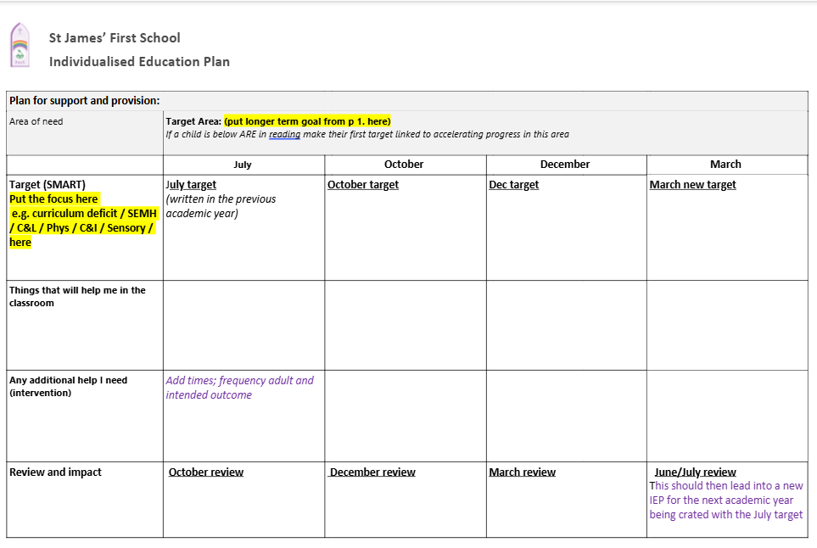
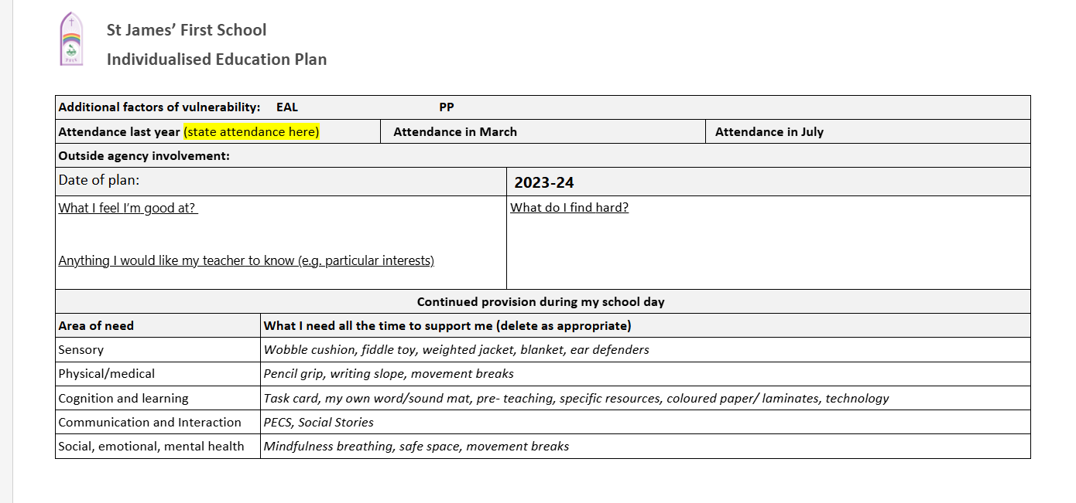
An example of part of an IEP (For GDPR reasons the whole IEP is not shared)

Appendix Three

ADHD / ADD | Attention Deficit Hyperactivity Disorder
ASD / ASC | Autistic Spectrum Disorder (ASD)/ Autistic Spectrum Condition (ASC)
BESD | Behaviour, Emotional and Social Difficulty
CAF | Common Assessment Framework
CAMHS | Child and Adolescent Mental Health Services
EAL | English as an Additional Language
EHC Plan | Education and Health Care Plan
EP | Educational Psychologist
HI | Hearing Impairment
ILP | Individual Learning Plan
LAC | Looked after Children
LGB | Local Governing Board
MLD | Moderate Learning Difficulty
OT | Occupational Therapy/Therapists
SALT | Speech and Language Therapy/Therapist
Spld | Specific Learning Difficulties
SEN | Special Educational Needs
SEND | Special Educational Needs and Disability
SENDCO | Special Educational Needs Coordinator
SEN Code of Practice | The legal document that sets out the requirements for SEN
TA | Teaching Assistant
Team Around the Child | Team Around the Child
VI | Visually Impaired

